

Presented by:

Mohamed Adel Melad Abd_Elhameed Youssef

Subject: Synopsys Prime Time Tool

Under supervising of:

Eng: Mohamed Zaiton

**STA minimum constrain file for hold violations.**

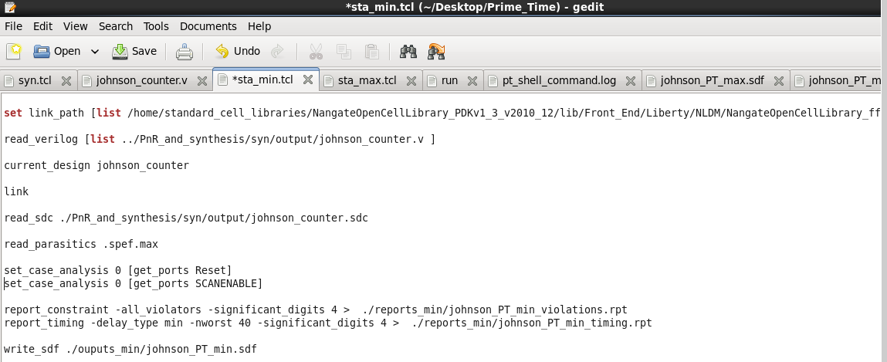

**Report of all violations:** only one violated constraint that I know it (no Area=zero, but I want to make the prime time tool do its best for minimize the Area).

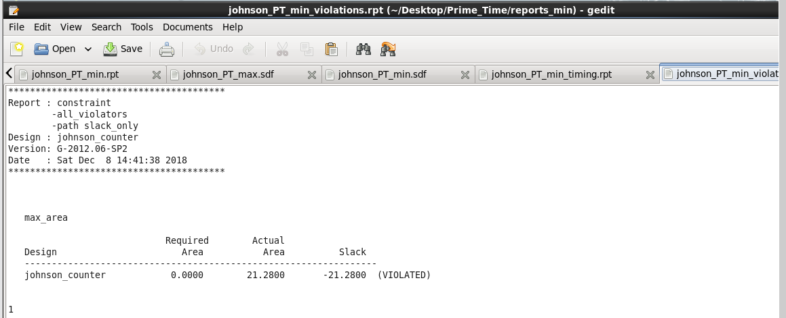

**The output standard delay format file for min report.**

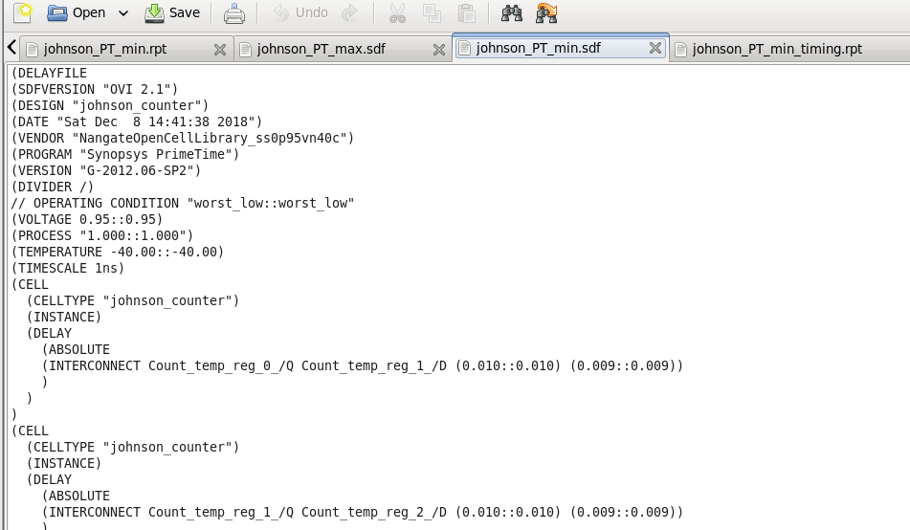

**STA maximum constrain file for hold violations.**

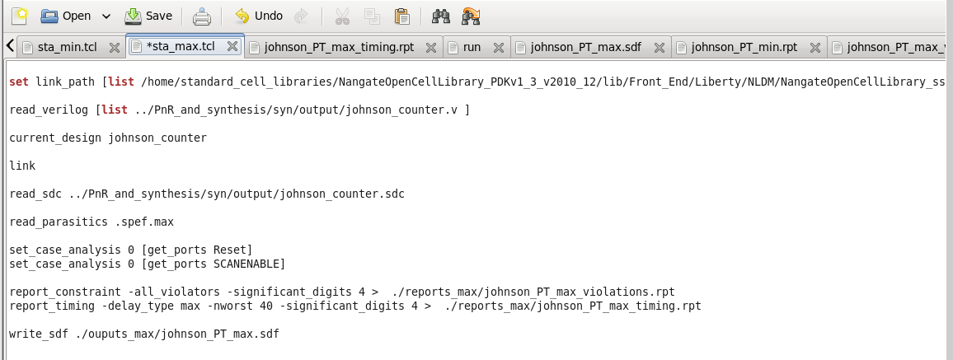

**Report of all violations:** is the same file that I put it previously for the same reason.

**The output standard delay format file for max report.**

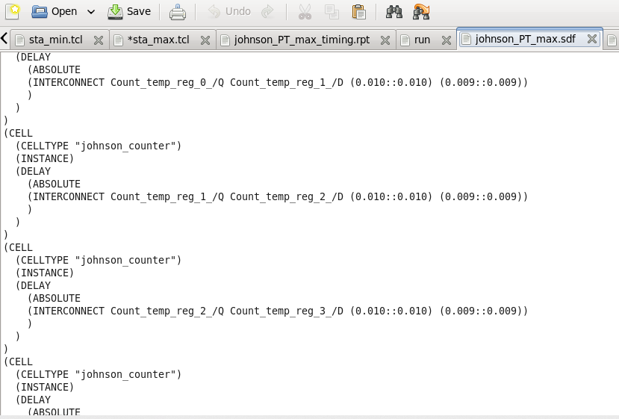

**The output timing report.**

